A Project Report On

**“Social Media Platform”**

SUBMITTED IN THE PARTIAL

FULFILLMENT OF THE

REQUIREMENT FOR THE AWARD OF

THE DEGREE OF

**BACHELOR OF TECHNOLOGY**

In

Computer Science Engineering

Submitted by

**Dhiraj Kumar Gupta (12500120104)**

**Rohit Kumar Singh (12500120064)**

**Raushan Kumar (12500120164)**

Under the esteemed guidance of

**Mr. Soubhik Ghosh**

Asst. Professor

Department of CSE



Department of Computer Science and Engineering

**Bengal College of Engineering and Technology**

Durgapur, W.B.



Department of Computer Science and Technology

**Bengal College of Engineering and Technology**

Durgapur, W.B.

**CERTIFICATE OF APPROVAL**

The project entitled **“Social Media Platform”** submitted by **Dhiraj Kumar Gupta (12500120104)**, **Rohit Kumar Singh (12500120064)** and **Raushan Kumar (12500120164)** under the guidance of **Asst. Professor Mr. Soubhik Ghosh**, is hereby approved as creditable study of engineering subject to warrant its acceptance as a pre-requisite to obtain the degree for which it has been submitted. It is understood that by this approval the undersigned don’t necessary endorse or approve any statement made, opinion or conclusion drawn therein but approve the project only for the purpose for what it is submitted.

Mr. Soubhik Ghosh Prof. Sk. Abdul Rahim Principal

Asst. Prof. H.O.D. BCET, Durgapur

Dept. of CSE Dept. of CSE



Department of Computer Science and Technology

**Bengal College of Engineering and Technology**

Durgapur, W.B.

**UDERTAKING**

We, **Dhiraj Kumar Gupta (12500120104)**, **Rohit Kumar Singh (12500120064)**, and **Raushan Kumar (12500120164)**, B. Tech, 7th Semester (Computer Science and Engineering), hereby declare that our project entitled **“Social Media Platform”** is our own contribution. The work or ideas of other people which are utilized in this report has been properly acknowledged and mentioned in the reference. We undertake total responsibility if traces of plagiarism are found at any later stage.

**Dhiraj Kumar Gupta**

**12500120104**

**Rohit Kumar Singh**

**12500120064**

**Raushan Kumar**

**12500120164**

**ACKNOWLEDGEMENT**

We would like to thank our respected HOD **Prof. Sk. Abdul Rahim** for giving us the opportunity to work on the topic of our choice which is on **“Social Media Platform”**. Nonetheless, we would like to thank our project guide **Asst. Prof. Mr. Soubhik Ghosh**, whose valuable guidance has helped us to complete this project. His suggestions and instructions have served as the major contributor towards the complete of this project.

We would also like to express gratitude towards our friends and every person who helped in every person who helped in every little way by giving suggestion. We are also thankful to the college for providing necessary resources for the project.

**Table of Contents**

List of Figures

List of Tables

List of Abbreviations

ABSTRACT

1. INTRODUCTION
2. REVIEW OF LITERATURE
3. REPORT ON THE PRESENT INVESTIGATION
4. PROPOSED METHOD
5. DFD, ER DIAGRAM, ETC.
6. RESULT AND DISCUSSIONS
7. FUTURE SCOPE
8. CONCLUSIONS

REFERENCES

List of Figures:

|  |  |  |
| --- | --- | --- |
| Fig. No. | Name of Figure | Page No. |
| 1 | Spring Boot React Full-Stack Architecture | 10 |
| 2 | Frontend React Folder Structure | 16 |
| 3 | Backend Spring Boot Folder Structure | 17 |
| 4 | Connecting to MySQL Database Dockers container | 17 |
| 5 | User Register/Sign-Up Page | 18 |
| 6 | User Sign-In Page | 19 |
| 7 | Spring MVC Workflow | 22 |
| 8 | Social Media Flowchart | 22 |
| 9 | Level-1 DFD | 23 |
| 10 | Level-2 DFD | 23 |
| 11 | ER Diagram/Database Schema | 24 |
| 12 | User Landing Page | 25 |
| 13 | User Dashboard/Homepage | 25 |

List of Tables:

1. Review of Literature……………………………………………………… Page 13-14

List of Abbreviations:

**Abbreviation** **Full-Form**

HTML HyperText Markup Language

CSS Cascading Style Sheets

MySQL My Structured Query language

REST Representational State Transfer

API Application Programming Interface

UI User Interface

JWT JSON Web Tokens

CI/CD Continuous Integration and Continuous Deployment

MVC Model-View-Controller

TDD Test Driven Development

DFD Data Flow Diagram

ER Diagram Entity Relation Diagram

**ABSTARCT**

The use of social media websites and Smartphone applications with the internet connected to the device to keep a connection with family members and friends is known as social networking. A broader image of social network is that many big significantly based marketers are seeking to engage customers using social networking itself. Social networks have capabilities to entertain both the purposes, social purpose and a business purpose.

A growing number of people are interacting on the web to express and share their views and knowledge of products and brands through social networks. For consumers, some social networks’ profiles serve as a reference in their purchasing decision process, since these profiles are perceived as giving their personal unbiased opinion.

Obviously, now, the apparent image of social media appears like a misrepresentation.

In past few years, we have seen that innovation has brought us together from where we

started and social network nearly appears as though it is a totally extra ordinary technology.

**Chapter-1**

**INTRODUCTION**

1.1 Overview

Our social media platform is a secured and user-friendly platform, where users can share images and video content and that can be visible to the audience across the globe. This website is our pre-built social media website that helps people to communicate like in an Instagram like app. Our Social media platform project script has several unique features. Features can be added, deleted, and modified easily in the project. We provide a simple, easy & seamless user experience. And our website script is optimized to support numerous operations in real-time, with minimal delay.

Social media platforms have become integral parts of people's lives, offering avenues for communication, networking, and expression. Building upon this premise, our project aims to develop a feature-rich social media website utilizing React.js and Spring Boot.

1.2 Spring Boot React Full-Stack Architecture Fig-1

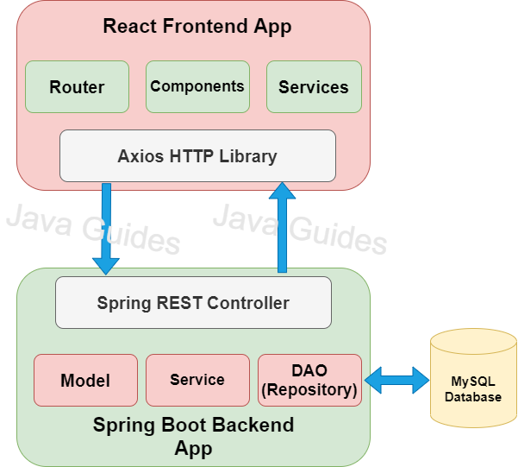1.3 Purpose and Scope of the Report

It was troublesome years back to speak with companions or family living in far off and faraway places, on account of innovation that isn't an issue any longer. Interpersonal interaction is becoming large in India and rest of the world with an ever-increasing number of clients going along with it consistently.

On these sorts of systems, we get together recognizable people or complete outsiders whom we share comparative enthusiasm with. On the off chance that the prior pattern was making affiliations and gatherings truly, the current age has confidence in making on the web networks and structures to talk about issues identified with different and assorted points.

The current framework is grown with the end goal that an enlisted client looks after his/her own profile and could likewise look through other comparable friend profiles over the application. An enlisted client can send companion demands over the site.

Scope:

* This framework gives clients to enroll their different kinds of social profiles, individual, proficient.
* The framework gives clients for transferring piece text data, pictures, or information documents to companions. Client may keep up the piece book whatever pieces he has send to clients.
* The framework gives client to transfer the photographs with the goal that client can keep up possess collection.
* This framework gives client to join the networks as indicated by their situation.
* This framework gives the client to keep up their companion rundown and client can refresh their companion list.

1.4 Background and Planning

* Defining Requirements: Discuss the essential features to include in the project, such as user profiles, image sharing, comments, likes, following/follower system, etc.
* System Architecture and Design: Outline the system architecture, database structure, and wireframes to plan the layout and functionalities of the website.

1.5 Domain Study

Today, social networking site use is a major activity for internet users from a wide range of demographic groups. Younger adults are especially avid adopters, but social networking continues to grow in popularity for older adults as well. Six out of ten internet users ages 50-64 are social networking site users, as are 41% of those ages 65 and older. Although online seniors are less likely than other age groups to use social networking sites, adoption rates for those 65 and older have tripled in the last four years.

The main types of social networking services are those that contain category places (such as former school year or classmates), means to connect with friends (usually with self-description pages), and a recommendation system linked to trust. Popular methods now combine many of Facebook, YouTube, LinkedIn, Instagram, Pinterest, Tumblr and Twitter widely used worldwide. Many of these early communities focused on bringing people together to interact with each other through chat rooms, and encouraged users to share personal information and ideas via personal web pages by providing easy-to-use publishing tools and free or inexpensive web space.

1.6 Objective

* To have attractive and Secure Register and Login page to access
* Make new user account in a more user-friendly way, and proper validation of details
* Search people easily on entire network
* Send friend request to other users to make friends
* Add friends to your friend list, accept request
* Creating a public profile having social, professional and personal information
* Ease of editing of profile anytime
* Chat with friends
* Upload and share images on network
* Add, Search and Shares videos of YouTube
* Send messages to other friends
* Reply directly to incoming user messages

**Chapter-2**

**LITERATURE SURVEY**

The Web-based social networking services make it possible to connect people who share interests and activities across political, economic, and geographic borders. Through e-mail and instant messaging, online communities are created where a gift economy and reciprocal altruism are encouraged through cooperation. Information is suited to a gift economy, as information is a non-rival good and can be gifted at practically no cost.

Facebook and other social networking tools are increasingly the object of scholarly research. Scholars in many fields have begun to investigate the impact of social- networking sites, investigating how such sites may play into issues of identity, privacy, social capital, youth culture, and education.

Several websites are beginning to tap into the power of the social networking model for philanthropy. Such models provide a means for connecting otherwise fragmented industries and small organizations without the resources to reach a broader audience with interested users. Social networks are providing a different way for individuals to communicate digitally. These communities of hypertexts allow for the sharing of information and ideas, an old concept placed in a digital environment.

In 2011, HCL Technologies conducted research that showed that 50% of British employers had banned the use of social networking sites/services during office hours.

|  |  |  |  |  |
| --- | --- | --- | --- | --- |
| Sl.No. | Author | Year | Title | Remarks |
| 1 | Kai vom Brocke, Jan  Richter, Daniel  Riemer | 2011 | Social  Network  using Internet | The makers recognize four winning floods of research and review the key responsibilities to the field. The review reveals that the investigation field is partitioned and doesn't yet energize a general appreciation of the miracle. Explicitly research is particularly inclined towards certain customer social events. Further, implications for a corporate setting are discussed. In doing in that capacity, three settings of usage are isolated: Social framework areas (SNSs) for 1) choosing and capable business improvement, 2) relationship help in appropriated work settings, and 3) relationship with end customers. The makers talk about SNS prospects, repercussions of existing ISN research and future research openings. In summary, they attempt to add to an unrivaled understanding of the wonder of ISN and to making available the back-and-forth movement domain of ISN investigate for the more broad Enterprise 2.0 system. |

Literature Review:

* React.js: React.js simplifies the process of building interactive user interfaces by breaking them down into reusable components. Its virtual DOM implementation enhances performance by minimizing DOM manipulation.
* Spring Boot: Spring Boot facilitates rapid application development by providing auto-configuration and convention over configuration. It integrates seamlessly with various Spring modules, enabling the creation of enterprise-grade applications with minimal effort.
* Social Media Website Development: Developing a social media website entail addressing challenges such as user scalability, real-time communication, and content management. Utilizing modern technologies like React.js and Spring Boot can streamline development and improve user experience.

**Chapter-3**

**REPORT ON PRESENT INVESTIGATION**

3.1 System Description

Hardware Spec.-

* Processor Name: Dual Core
* Processor Speed: 3.2GHz
* RAM: 12GB
* SSD Capacity: 256GB
* Display Monitor- 15.6inch Laptop Screen
* Keyboard & Mouse: Wireless

3.2 Technologies Used

* Java- programming language
* Spring Boot- Java-based framework
* HTML- markup language
* CSS- style sheet language
* JavaScript- programming language
* React.js- Front-end JavaScript library
* VS Code- IDE
* Docker Desktop- software platform
* MySQL- RDBMS
* MySQL Workbench- visual database design tool
* Postman API- API platform

3.3 Architecture Overview

The system follows a microservices architecture, with the frontend implemented using React.js and the backend using Spring Boot. Communication between the frontend and backend occurs via RESTful APIs.

3.4 Frontend Design with React.js

The frontend comprises modular components responsible for rendering UI elements, handling user interactions, and making API requests to the backend. React Router facilitates client-side routing for a seamless user experience.

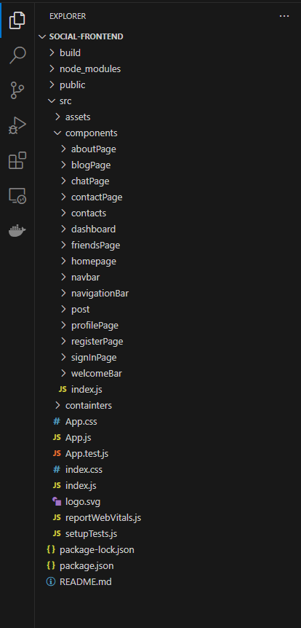

Fig: Frontend React Folder Structure

Fig-2

3.5 Backend Design with Spring Boot

Spring Boot serves as the backend framework, providing RESTful endpoints for user authentication, data retrieval, and media storage. Security measures such as JWT-based authentication are implemented to safeguard user data.

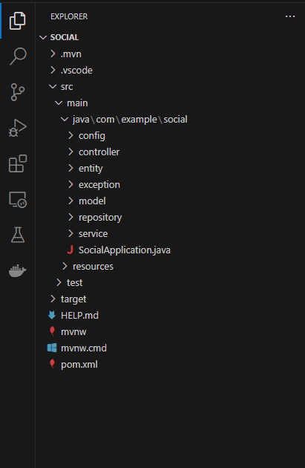

Fig: Backend Spring Boot Folder Structure

Fig- 3

3.6 Database Design

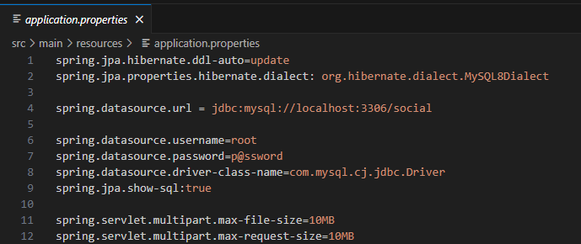MySQL is employed as the relational database management system, storing user information, messages, media metadata, and relationship data. The database schema is designed to ensure data integrity and optimize query performance.

Fig: Connecting to MySQL Database Dockers container Fig-4

3.7 Implementation

3.7.1 Setup and Configuration:

The development environment is set up with necessary dependencies including Node.js, npm, Java Development Kit (JDK), and MySQL database. Project scaffolding is done using create-react-app and Spring Initializer.

3.7.2 User Authentication:

User authentication is implemented using JSON Web Tokens (JWT), ensuring secure transmission of authentication tokens between the client and server. Users are required to sign up and sign in to access the platform's features.

3.7.3 User Sign-Up Module:

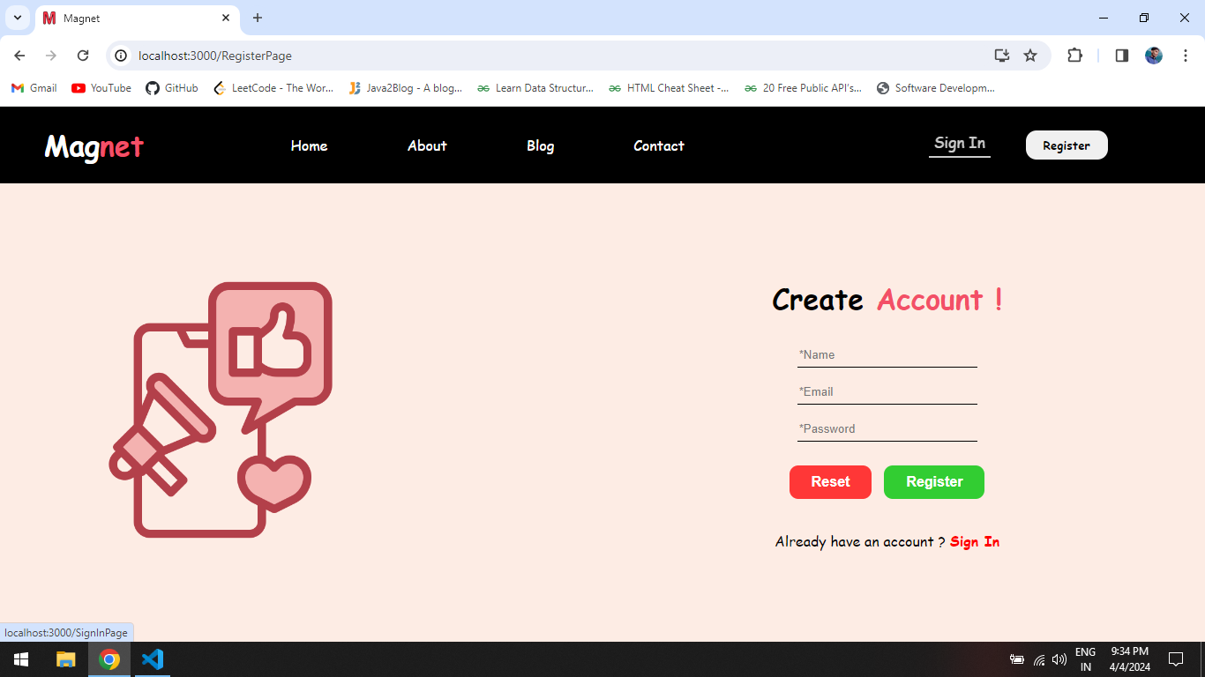The sign-up module allows new users to create accounts by providing basic information such as username, email, and password. Input validation and error handling mechanisms are in place to enhance user experience.

Fig: User Register/Sign-Up Page Fig-5

3.7.4 User Sign-In Module:

Authenticated users can sign in using their credentials, triggering the generation of JWT tokens for subsequent API requests. Authentication tokens are stored securely in local storage and utilized for accessing protected resources.

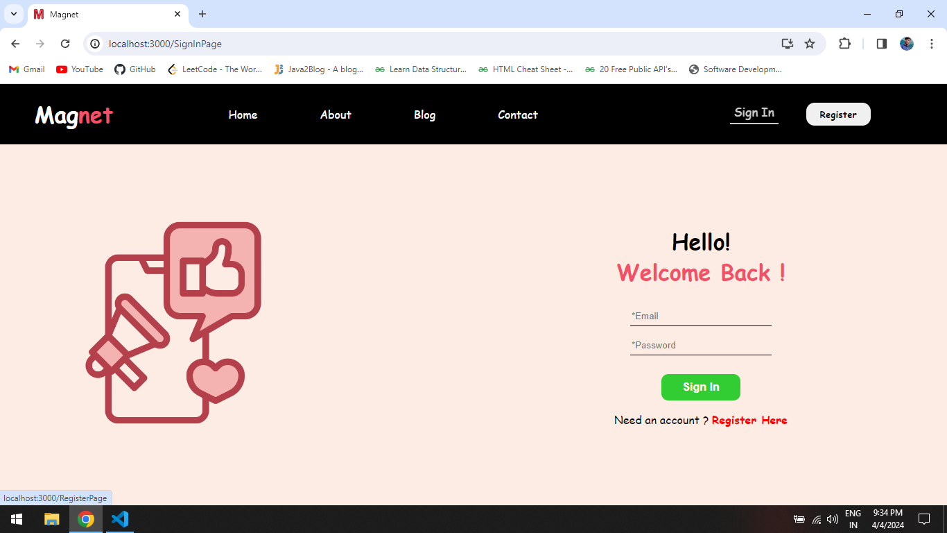Fig: User Sign-In Page Fig-6

3.7.5 Follow Functionality:

Users can follow other users to receive updates from their feeds. Follow relationships are stored in the database and used to generate personalized feeds for each user.

3.7.6 Messaging System:

The messaging system enables users to send and receive messages with their followers in real-time. WebSocket communication is utilized for instant message delivery, enhancing the platform's interactivity.

3.7.7 Media Upload Feature:

Users can upload photos and videos to share with their followers. Media files are stored on the server and associated metadata is stored in the database for retrieval and display on user feeds.

3.7.8 Feed Generation:

User feeds are dynamically generated based on followed users' activities, including uploaded media, status updates, and shared content. Feed algorithms prioritize relevant and engaging content to enhance user engagement.

**Chapter-4**

**PROPOSED METHODS**

1. Integration with Social Media APIs:

- Leveraging Spring Boot's capabilities, we'll develop a system to integrate with various social media platform APIs such as Facebook, Twitter, Instagram, etc. This integration will allow seamless extraction and management of data.

2. Data Retrieval Modules Development:

- Utilizing Spring's dependency injection and MVC architecture, we'll create modules specifically designed for data collection. These modules will fetch crucial metrics like user engagement, post analytics, demographics, etc., from the respective social media APIs.

3. Scheduled Data Updates:

- Implementing Spring's scheduling capabilities, we'll set up scheduled tasks to periodically retrieve and update data. This approach ensures that the analysis is based on the most recent information available, facilitating real-time insights.

4. Security Implementation with Spring Security:

- Employing Spring Security features, our system will prioritize the secure handling of sensitive user data obtained from social media platforms. This includes implementing authentication, authorization, and encryption to ensure data privacy and compliance with security standards.

5. Best Practices Adherence:

- Throughout the development lifecycle, we'll adhere to industry best practices such as test-driven development (TDD), ensuring the creation of robust, reliable, and maintainable code. Additionally, employing continuous integration/delivery (CI/CD) practices will streamline development processes, enhancing the efficiency of the system.

6. Scalability and Performance Optimization:

- Considering Spring Boot's scalability features, we'll design the system to handle large volumes of data efficiently. Implementing caching mechanisms and optimizing database interactions will ensure optimal performance even with increased data loads.

7. Logging and Monitoring:

- Implementing logging mechanisms using Spring Boot's capabilities will enable effective tracking of system activities and potential issues. Additionally, integrating monitoring tools for system health checks will facilitate timely identification and resolution of any performance bottlenecks.

8. Documentation and Maintenance:

- Thorough documentation of code and system architecture will aid in understanding and maintaining the developed system. This documentation will ensure that future updates or modifications can be executed seamlessly.

9. User Interface Development (Optional):

- Optionally, the development of a user interface using Spring Boot's support for frontend frameworks like Thymeleaf or React can be considered. This interface can provide a user-friendly dashboard to visualize and interact with the collected social media data.

By combining these methodologies within the Spring Boot framework, we aim to create a robust and efficient system for analyzing social media data, offering valuable insights for businesses and marketers.

**Chapter-5**

**DFD, ER DIAGRAM, ETC.**

Spring MVC Workflow:

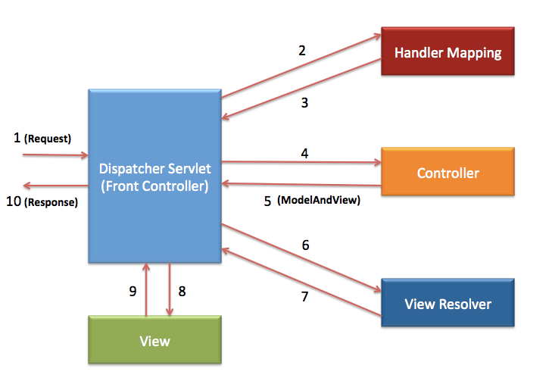Fig-7

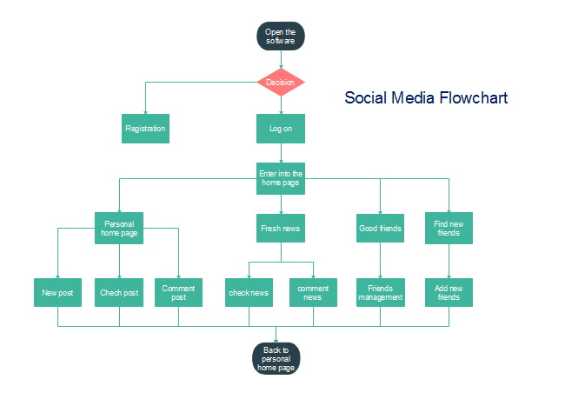Social Media Flowchart: Fig-8

Level-1 DFD:

Fig-9

Level-2 DFD:

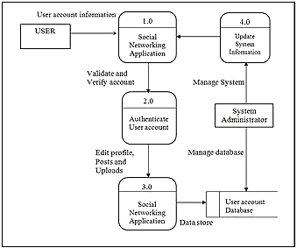

Fig-10

ER Diagram/ Database Schema:

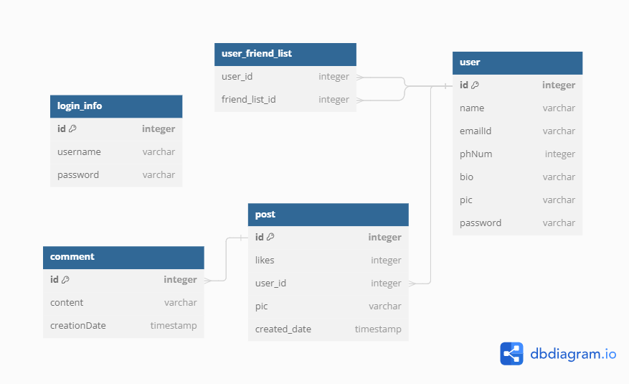

Fig-11

**Chapter- 6**

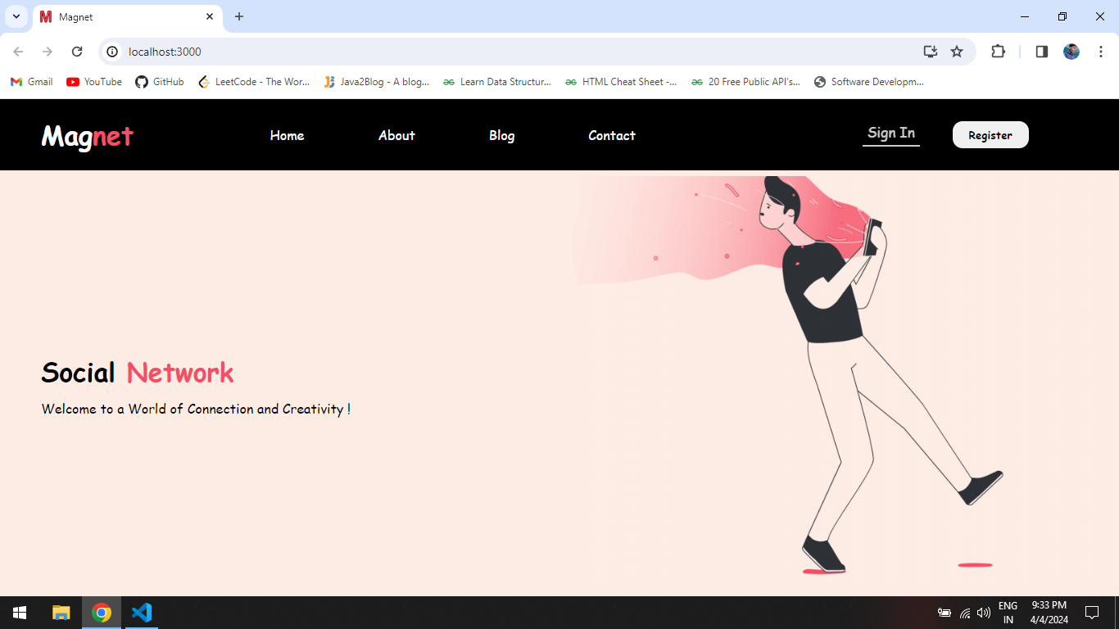**RESULT AND DISCUSSION**

Fig: User Landing Page Fig-12

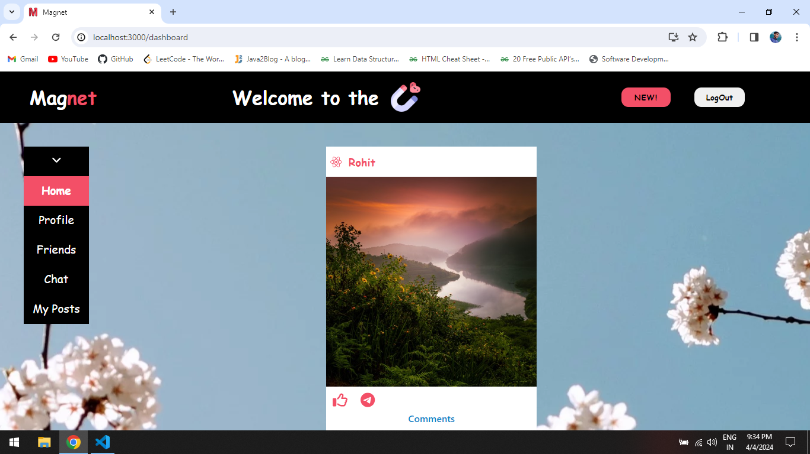

Fig: User Dashboard/Homepage Fig-13

Results:

1. Feature Implementation: Successfully integrated core functionalities (authentication, profiles, posting, commenting, following users).

2. Performance: System exhibited good performance with acceptable response times, ensuring a positive user experience.

3. User Engagement: Positive feedback on user interface; interactive features boosted user engagement.

Discussions:

1. Challenges: Challenges encountered during development include managing state consistency across components, optimizing media storage and retrieval, and ensuring compatibility across different browsers and devices.

2. Future Enhancements: Focus on scalability via caching mechanisms, advanced content algorithms, and refined notification systems.

3. Security Measures: Implemented industry-standard security practices to safeguard user data.

**Chapter-7**

**FUTURE SCOPE**

As technology advances, there are several future scopes for our own Social Media Website. Future enhancements may include implementing advanced features such as:

* Notifications: Implementing real-time notifications to alert users about new messages, follower activities, and relevant updates.
* Search Functionality: Introducing advanced search capabilities to enable users to discover content, profiles, and topics of interest.
* Geolocation Services: Integrating geolocation services to enhance user experiences such as location-based content recommendations and event discovery.
* Analytics Dashboards: Developing analytics dashboards to provide users with insights into their engagement metrics, audience demographics, and content performance.

Security Improvements:

* Enhanced Authentication: Strengthening user authentication mechanisms with additional layers of security such as multi-factor authentication (MFA) and biometric authentication.
* Data Encryption: Implementing end-to-end encryption for sensitive user data to protect against unauthorized access and data breaches.
* Vulnerability Assessments: Conducting regular vulnerability assessments and penetration testing to identify and address security vulnerabilities proactively.

Scalability Enhancements:

* Horizontal Scaling: Implementing horizontal scaling techniques to accommodate increasing user loads and ensure optimal performance during peak usage periods.
* Microservices Architecture: Refactoring the application into microservices to improve modularity, scalability, and maintainability.
* Caching Mechanisms: Enhancing caching mechanisms to minimize database queries and reduce latency, thereby improving overall system responsiveness.

**Chapter-8**

**CONCLUSION**

As we reflect on the journey of developing a social media website using React.js and Spring Boot, we recognize the immense potential and impact of modern web technologies in shaping the digital landscape. This project represents more than just the culmination of coding and design efforts; it embodies a vision of connectivity, innovation, and empowerment in the realm of social networking. The development process has been both challenging and rewarding, pushing us to explore new horizons in web development while addressing complex technical and design considerations. By harnessing the strengths of React.js and Spring Boot, we have been able to build a platform that not only meets the expectations of today's users but also anticipates their future needs.

In conclusion, the development of a social media website using React.js and Spring Boot represents a significant milestone in our journey towards creating innovative and impactful web applications. The project has demonstrated the effectiveness of modern technologies in building feature-rich, scalable, and secure platforms that cater to the diverse needs of users in the digital age. As we look towards the future, we remain committed to continuous improvement and innovation, striving to enhance the platform's functionality, performance, and user experience through ongoing research, development, and collaboration with stakeholders. With a focus on user-centric design, accessibility, and data privacy, we aim to create a social media platform that fosters meaningful connections, promotes inclusivity, and enriches the lives of users worldwide. The project has successfully developed a social media website with essential features using React.js and Spring Boot.

**REFERENCES**

[1] Thorpe, I 2011, ‘8 Uses for social media in aid work’, viewed 23 September 2011, <http://kmonadollaraday.wordpress.com/2011/03/14/8-uses-for-social-media-in-aid-work/>

[2] Zeng R, Li M. Social Media Use for Health Communication by the CDC in Mainland China: National Survey Study 2009–2020. *J Med Internet Res.*2020;22:e19470. doi: 10.2196/19470. [[PMC free article](https://www.ncbi.nlm.nih.gov/pmc/articles/PMC7744262/)] [[Google Scholar](https://scholar.google.com/scholar_lookup?journal=J+Med+Internet+Res&title=Social+Media+Use+for+Health+Communication+by+the+CDC+in+Mainland+China:+National+Survey+Study+2009%E2%80%932020&author=R+Zeng&author=M+Li&volume=22&publication_year=2020&pages=e19470&pmid=33151892&doi=10.2196/19470&)]

[3] Lopez M, Chan TM, Thoma B, et al. The Social Media Editor at Medical Journals: Responsibilities, Goals, Barriers, and Facilitators. *Acad Med.*2019;94:701–707. doi: 10.1097/ACM.0000000000002496

[4] Soltren, J 2005, Facebook: Threats to Privacy, MIT, Massachusetts.

[5] Castells, M 2009, Communication Power, Oxford University Press, Oxford.

[6] Stack Over-flow --> https://stackoverflow.com/

[7] Geeks for Geeks --> https://www.geeksforgeeks.org/

[8] Java2Blog --> https://java2blog.com/

[9] React.js Documentation: https://reactjs.org/docs/getting-started.html